The Inklings Institute of Canada:
"Allegory in Narnia, or being Edmund
and finding Jesus."
Tuesday, Sept. 25, TWU Fosmark Collegium, 7:00-8:30 pm

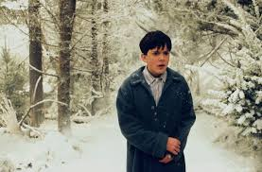
The Inklings Institute of Canada, housed in the English Dept. at Trinity Western University, is hosting an evening of discussion at Fosmark Collegium about interpretations of C. S. Lewis’s
Chronicles of Narnia.

The discussion will be led by Richard Bergen, TWU alumnus and Ph.D. candidate at UBC. C. S. Lewis understood very well that his fantasy stories – and The Lion, the Witch and the Wardrobe in particular – would invite allegorical interpretation, and in his thought, this fact would actually confirm their status as being mythical fairy stories. Moreover, Lewis would not have opposed allegorical interpretation as such, provided that it be done well and without readers thinking they had the one and only correct interpretation, and that the reader in question not designate the text at hand "an allegory."

There are things about The Lion, the Witch, and the Wardrobe that strongly invite allegorical interpretation, and we as readers have no difficulty coming to new insights about Jesus through Aslan, and we can easily see ourselves in the Pevensie children that walk through Narnian landscape. Richard's personal favourite is Edmund - the blighter who become "The Just," and he will present some of his "allegorical interpretations" on how this boy can serve as a figure, an exempla, to provide insights about how our souls can relate in some way to the divine.

The evening will begin with a presentation by Richard, with lots of time for refreshments and questions to follow. Everyone is welcome: just bring an interest in C. S. Lewis and a desire to dig deeper....

